MODERNIZING CAMPUS ELECTIONS: THE USTP OROQUIETA ELECTORAL COMMISSION VOTING SYSTEM

TITLE PAGE

A Capstone Project and Research Study
Presented to the
Department of Information Technology
University of Science and Technology of Southern Philippines
Oroquieta City



In Partial Fulfillment of the Requirements for
Capstone Project and Research Study Leading to the Degree in
Bachelor of Science in Information Technology

REDJAN PHIL S. VISITACION
KURT COLLIN CLINT MABALOD
LOLLAINE GUILL J. PUERTE
VON JUSHUA PEJE

May 2026


APPROVAL SHEET

TABLE OF CONTENTS

TITLE PAGE i
APPROVAL SHEET ii
TABLE OF CONTENTS 1
LIST OF TABLES 4
LIST OF FIGURES 5
CHAPTER I 6
1.1. Background of the Study 6
1.2. Statement of the Problem 8
1.3. Statement of the Objectives 9
1.4. Significance of the Study 10
1.5. Scope and Limitations of the Study 11
1.6. Definition of Terms 13
CHAPTER Ⅱ 16
2.1 Review of Related Literature 16
2.2 Review of Related Application 19
2.3 Synthesis and Gap Analysis 29
CHAPTER III 32
3.1 Research Methodology 32
3.2 Data Gathering Procedure 36
3.2.1 Research Instrument 36
3.2.2 Sampling Method 37
3.2.3 Statistical Treatment of Data 38
3.3 Description of the Current System 39
3.4 System Architecture and Development 41
3.4.1 Overview of the Proposed System 42
3.4.2 System Objectives 43
3.4.3 System Tools and Requirements 44
3.4.4 System Flow/Functions (Diagram: FLOWCHART) 49
3.4.5 Scope and Limitations of the System 50
3.4.6 Calendar of Activities (Gantt Chart) 51
3.5 Conceptual Design and Implementation 53
3.5.1 Database Design (Diagram: Entity Relationship Diagram.) 53
3.5.2 System Design 55
BIBLIOGRAPHY 60
APPENDICES 62
APPENDIX A 63
APPENDIX B 65

LIST OF TABLES
Table 1. Comparison of Related Systems 28
Table 2. Likert Scale Table 39
Table 3 Programming Languages uses in Development 45
Table 4 Scripting Language use in development 45
Table 5 Markup Language uses in Development 45
Table 6 Style Sheet Language uses in Development 45
Table 7. Hardware Requirements 46
Table 8 Software Requirements 47

LIST OF FIGURES
Figure 1. MSU Lopez Jaena User Interface 20
Figure 2. COMELEC Automated Election System Interface 22
Figure 3. POLYAS Online Voting System Interface 24
Figure 4. E-Voting System (SPUP) Interface 25
Figure 5. SSC FIRVS Interface 26
Figure 6 Agile Scrum Development Process 33
Figure 7 System Architecture and Development 41
Figure 8 Flowchart Diagram 49
Figure 9 Gantt Chart 51
Figure 10 Database Design 53
Figure 11 Use Case Diagram 55
Figure 12 Context Diagram 57
Figure 13 Dataflow Diagram 58

CHAPTER I
INTRODUCTION
This chapter provides the foundational context, problem statement, objectives, significance, scope and limitations, and definitions of key terms pertinent to the Electoral Commission Voting System (ECVS). It underscores the necessity of substituting the manual student election procedure at the University of Science and Technology of Southern Philippines Oroquieta Campus (USTP Oroquieta) with a secure, automated, face-verified, cryptographic ledger-based, and network-restricted digital voting system. The goal of the project is to improve the security, operational efficiency, accuracy, transparency, and integrity of the electoral process.

1.1. Background of the Study
Student elections are vital for developing leadership abilities while students learn democratic principles and their school opinions are protected through student voting rights (International IDEA, 2021). The University of Science and Technology of Southern Philippines Oroquieta Campus operates its campus elections through its Electoral Commission which goes by the name ELECOM. The current electoral process continues to operate through manual methods which still exist. This process requires students to vote using paper ballots through in-person voting, and all votes are counted manually.
Manual elections often result in long queues, time consuming vote tallying, ballot misplacement, human errors, and delayed announcement of results (International IDEA, 2021; ACE Electoral Knowledge Network, 2022). As the student population increases, these challenges become more evident. Interviews conducted with members of the University Student Government (USG) and the Electoral Commission brought to light a number of persistent issues: insufficient voting resources, challenges in verifying voter participation, the lack of real time monitoring capabilities, and an absence of transparent result auditing procedures. These shortcomings serve to undermine operational efficiency, compromise transparency, and, as a consequence, potentially diminish student trust in the electoral process.
Consequently, this research advocates for the creation of the Electoral Commission Voting System (ECVS), a mobile and web based election platform. The platform will be constructed using Flutter for the mobile application, a Python based API (such as FastAPI or Django REST Framework) for backend processing, PostgreSQL Database for database management, and cryptographic hashing and ledger-based verification for secure vote recording and verification (Yaga et al., 2021; Zheng et al., 2022).

1.2. Statement of the Problem
The current manual election process at the University of Science and Technology of Southern Philippines (USTP) Oroquieta Campus faces several challenges that affect efficiency, accuracy, transparency, and security. Based on interviews and observations conducted with students, the University Student Government (USG), and the Electoral Commission (ELECOM), the following problems were identified:
- Time Consuming Manual Vote Counting: The manual counting of votes requires significant time and effort, causing delays in releasing election results and reducing operational efficiency.
- Difficulty in Verifying Voter Participation: The existing process lacks a centralized system for monitoring voter participation, making voter tracking prone to errors and incomplete records.
- Human Errors in Vote Counting: Manual tallying increases the risk of miscounting, duplicate entries, and inaccurate recording of votes, which may affect the credibility of election results.
- Limited Transparency and Auditability of Election Results: The current system does not provide real-time monitoring and reliable auditing mechanisms, reducing transparency and stakeholder trust in the election process.
- High Consumption of Physical Resources and Inefficient Election Management: The use of paper ballots and manual validation consumes excessive physical resources and may lead to operational difficulties during elections.
- Weak Voter Identity Verification: The current election process lacks biometric or facial verification mechanisms to ensure that only legitimate students can access and use the voting system.

1.3. Statement of the Objectives
The general objective of this study is to design and develop an Electoral Commission Voting System (ECVS) that enhances the efficiency, accuracy, security, and transparency of campus elections at the University of Science and Technology of Southern Philippines (USTP) Oroquieta Campus. Specifically this study aims to:

- To evaluate the efficiency and accuracy of the ECVS in conducting elections and generating results compared to the existing manual system.
- To assess the security and reliability of the ECVS in protecting votes and ensuring proper system performance under varying conditions.
- To determine the usability, transparency, and overall acceptability of the ECVS among students and election administrators.

1.4. Significance of the Study
The study benefits various stakeholders, who will receive significant advantages from its results.
Electoral Commission (ELECOM): The Electoral Commission (ELECOM) receives an automated election management system which functions as a centralized system to manage all campus elections. The system enables real time election activity monitoring through its automated processes which improve accuracy and transparency while its secure data management system maintains operational trustworthiness.
University Administration: The University Administration system will enhance student election processes by delivering a transparent and secure electoral system that operates efficiently. The objective of the program is to provide voting results to the decision makers, quickly and cost-effectively when compared to standard electoral processes.
Students (Voters): The voting system provides students with access to voting through its mobile and web platforms which enable students to cast their votes through an easy to use voting system. The system enables students to vote from their devices while accessing election results which establish system transparency and build trust in the electoral process. The inclusion of face verification technology enhances voter security by ensuring that only authorized students can access and use the voting system.
Candidates: The system offers an election procedure which maintains vote integrity through its precise vote counting system and its protected vote storage system. The election results will be delivered to candidates through a reliable system which provides them with results in a brief period, thus reducing disputes and increasing their confidence in the outcomes.
Developers and Future Researchers: The study provides system developers and future researchers with electronic voting systems as their reference point. The framework establishes the foundation for digital voting platforms which will use modern technologies including blockchain, mobile applications and secure network systems.

1.5. Scope and Limitations of the Study
The system manages its automated tasks together with its administrative duties which help support the student election procedure at the University of Science and Technology of Southern Philippines (USTP) Oroquieta Campus. The system consists of two primary components which students can access through a mobile voting application and administrators can use through a web based platform which serves as the Electoral Commission's administrative system. Students can vote securely through the Flutter based mobile application while administrators use the web interface to control candidate management and track voting progress and produce election outcomes.
The system consists of four main components which include a user authentication system that confirms student identities, a candidate management system that handles election information, a voting system that enables voters to submit their ballots in a safe manner and face verification system for voter authentication. The system connects a Python-based REST API which operates through FastAPI or Django REST Framework to handle backend tasks while PostgreSQL functions as the main repository for data storage and management.
The system utilizes cryptographic hashing and ledger-based recording mechanisms to establish secure vote verification and transparent vote monitoring, which help protect voting records from unauthorized modification. The system implements dynamic network restricted voting which allows users to vote only when they are connected to authorized school networks. The system offers automatic vote counting functions which produce reports that provide instant election results while improving operational transparency and efficiency during the entire election period.
The system dedicated its development work exclusively to USTP Oroquieta campus elections which it uses to conduct voting operations. The system prevents all external users from accessing its voting function because only authorized school network users have permission to vote.
The system needs both a constant internet connection and correct campus network setup for its proper operation. System access and voting processes will be interrupted by network outages and problems with internet connection.
The blockchain system operates on a private or simulated blockchain environment and does not conduct any public cryptocurrency transactions.

1.6. Definition of Terms
Administrative Dashboard - A web based interface used by the Electoral Commission to manage election operations, including candidate management, monitoring voting activities, configuring network restrictions, and generating election reports.
Automated Vote Counting - A system feature that automatically processes and tallies votes cast by students, with results verified through database and blockchain records to ensure accuracy and integrity.
Backend System - The server side component responsible for processing requests, handling authentication, managing data, and controlling system operations using frameworks such as FastAPI or Django REST Framework.
Blockchain Technology - A cryptographic ledger-based mechanism used in this study to securely record voting transactions and detect unauthorized modifications.
Dynamic Network-Restricted Vote Casting - A security feature that allows students to cast votes only when connected to authorized campus networks.
Electoral Commission Voting System (ECVS) - The proposed digital voting platform designed for USTP Oroquieta Campus to facilitate secure, efficient, and transparent election processes through mobile and web technologies.
Face Verification – A biometric authentication process that compares a student’s facial features with stored records to verify identity before granting access to the voting system.
PostgreSQL Database - A centralized database system used to store and manage student records, candidate information, voting data, and election settings.
User Authentication - The process of verifying a student’s identity before granting access to the voting system to ensure that only authorized users can participate in the election.
User Module - The component of the system that provides an interface for students to log in, view candidates, and cast their votes.

CHAPTER Ⅱ
REVIEW OF RELATED LITERATURE

2.1 Review of Related Literature
Student elections serve a vital function in educational institutions because they enable students to practice democratic voting rights while developing their leadership skills and establishing their own student organizations. Many schools use traditional election methods, which require voters to cast their votes through paper ballots that election workers count by hand. According to International IDEA (2021), traditional voting methods create several problems because they take a long time to count votes and announce results while human mistakes decrease confidence in the voting system. The current voting systems become apparent as student populations continue to grow because they need better systems that operate with higher reliability and efficiency.
The advancement of information technology has led many institutions to adopt electronic voting systems. The systems enable users to cast their votes using computers and mobile devices which improves both the speed and accessibility of the voting process. The systems help decrease paper usage while they streamline the procedure of counting and tabulating votes. Data security issues and voter privacy protection problems continue to pose major obstacles for the systems despite their technological benefits (ACE Electoral Knowledge Network, 2022).
The implementation of blockchain technology provides a solution which successfully solves these specific issues. The system of blockchain functions as a decentralized digital ledger which maintains secure and clear transaction records across different network systems. According to Yaga et al. (2021), blockchain ensures data immutability, meaning that once data is recorded, it cannot be altered without network consensus. The voting systems use this feature to build trust which stops people from changing their votes. Election results maintenance uses a secure chain which connects each vote as a block through cryptographic hashing (Zheng et al., 2022).
Mobile application development serves as a fundamental component which helps update digital voting systems. The Flutter framework enables developers to build applications that run on both Android and iOS devices through its cross-platform development capabilities. Mobile-based voting systems which use smartphones for voting purposes, enable students to participate in elections with greater ease and increased voting turnout.
The process of user authentication stands as a vital element which protects electronic voting systems from unauthorized access. Authentication mechanisms verify the identity of voters before granting access which ensures that only authorized individuals can participate. The mechanisms stop multiple voting which would damage election integrity through their ability to prevent fraudulent voting activities. The system protection receives additional strength from network-based security measures which exist beyond authentication. The system protects its voting system through network restrictions which limit access to approved areas that contain campus networks. The system achieves higher efficiency and transparency through its capability to generate immediate election results through its automated vote counting system. The system achieves increased reliability through its secure voting system which operates with multiple security features.
Academic institutions in the Philippines have implemented electronic voting systems which researchers from their country have studied through international studies and various Philippine-based research projects. A study conducted at Mindanao State University demonstrated how online voting systems decreased manual voting errors while they simultaneously enhanced electoral process productivity. Research at the University of the Philippines proved that secure authentication systems function as essential security measures which stop unauthorized users from gaining access to restricted systems. The Commission on Elections (COMELEC, 2022) issued a report which stated that electoral processes gain increased transparency through digital technology integration while the system reduces election fraud and boosts election credibility. The report further noted that automated systems provide real time monitoring capabilities which traditional manual voting systems do not offer to their users.

2.2 Review of Related Application
The research examines current electronic voting systems and their related applications which educational institutions use to enhance their electoral processes through improved efficiency and accurate results and transparent operations. Institutions which currently use traditional manual voting methods to conduct their elections have implemented digital voting systems which solve three common problems that lead to delayed vote counting and human mistakes and reduced election management transparency. The different electronic voting systems use various functions which include web based, mobile voting systems, automated vote counting systems, secure authentication methods and centralized database systems to create efficient election processes. The voting systems help to increase voting access while decreasing the need for administrative tasks and producing more exact election results. The Electoral Commission Voting System (ECVS) comparison shows its system features and functionalities to existing applications which already exist in the market. The system capabilities section shows what the system can do while existing solutions show how the system operates. The system comparison creates the foundation which assesses current technological systems while demonstrating the specific deficiencies that the ECVS system aims to resolve through better transparency, improved coordination, enhanced security and greater operational efficiency in campus election management.
Automated School Online Voting System for MSU Lopez Jaena
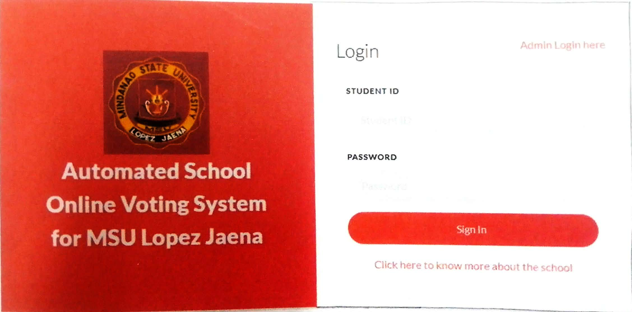

Figure 1. MSU Lopez Jaena User Interface

The Automated School Online Voting System for MSU Lopez Jaena was developed to improve the efficiency and reliability of student elections conducted at Mindanao State University Lopez Jaena Campus. The project was developed to address the difficulties that arise during standard electoral procedures which depend on both paper ballots and manual vote counting methods. The conventional voting system demands that election officials dedicate long hours to their tasks which leads to increased workload and results in errors during both vote counting and recordkeeping processes. The researchers created an online voting system that enables students to vote through digital means to solve existing voting system problems.
The system was developed as an undergraduate thesis presented to the Department of Information Technology at University of Science and Technology of Southern Philippines Oroquieta Campus. The platform was built to support registered students who needed to access the system for the purpose of viewing candidate listings and performing electronic voting. The system supplied election officials with an administrative interface that permitted them to manage candidate information while tracking voter turnout and the system produced election results automatically.
The system provides essential functions which include voter authentication and digital ballot presentation and automated vote tallying and result generation. The system contains functions which restrict access to authorized voters and enable each student to cast only a single vote. The system uses an automated vote counting mechanism which removes manual tabulation requirements and enables faster and more accurate election result generation.
The automated voting system implementation produced better election management results together with higher operational efficiency. The system decreased election time while it reduced human errors during vote counting and it simplified the process of organizing student elections. The digital platform enhanced record management by storing election data securely in a central database system.
Digital technologies which enable modern election procedures operate within educational institutions through The Automated School Online Voting System for MSU Lopez Jaena demonstration. The system enables educational institutions to run student elections through its online voting platform which replaces traditional manual voting methods, thus creating an election process which operates with increased speed and organized efficiency and reliable results.

Commission on Elections (COMELEC) Automated Election System
Figure 2. COMELEC Automated Election System Interface

The Philippines Commission on Elections (COMELEC) has established an automated election system which will be used during national and local elections to improve vote counting processes and deliver precise election results and open electoral procedures. The system uses vote counting machines (VCMs) to automatically process ballots and produce election results with improved speed and dependable accuracy.
The automated election system decreases the need for people to participate in vote counting which leads to better election outcomes through reduced errors and increased accuracy. The system offers enhanced transparency because it can send election data almost immediately while it tracks election events as they happen. The system offers multiple benefits to users but it lacks modern technology because it does not implement blockchain security measures and it does not use network-based voting restrictions to establish secure access controls.
The proposed Electoral Commission Voting System (ECVS) requires secure advanced voting solutions because it uses blockchain technology together with network-based restrictions to enhance election security and reliability.


POLYAS Online Voting System
Figure 3. POLYAS Online Voting System Interface

The POLYAS online voting system enables organizations and institutions and universities to conduct safe and effective digital elections. The system allows administrators to create and manage ballots while determining voter eligibility and tracking election activities through a web-based system.
The official platform states that voters can complete the voting process through three main steps which involve creating ballots and authenticating eligible voters and launching the election with real-time monitoring capabilities. The system uses secure authentication techniques together with encrypted vote transmission to protect voter privacy and safeguard data.
The POLYAS system demonstrates that web-based voting systems enable users to access elections while conducting secure voting activities. The system fails to implement blockchain technology together with network-restricted voting, which the proposed Electoral Commission Voting System (ECVS) identifies as essential system elements.

E-Voting System: Enhancing Student Elections and Governance Through Digitalization
Figure 4. E-Voting System (SPUP) Interface

The research study "E-Voting System: Enhancing Student Elections and Governance Through Digitalization" from St. Paul University Philippines demonstrates its implementation of a web-based electronic voting system designed to improve student election processes. The system was developed to address common issues in traditional voting such as inefficiency, inaccuracy, and security problems.
The proposed system enables students to vote electronically through its web-based platform which ensures secure access and accurate vote processing. The system includes automatic vote counting functions, live result displaying capabilities, and better access options for students who want to vote. The system decreases the need for people to manually operate processes while it boosts efficiency in managing electoral operations.

Supreme Student Council Fingerprint Recognition Voting System (SSC FIRVS)
Figure 5. SSC FIRVS Interface

The Supreme Student Council Fingerprint Recognition Voting System (SSC-FIRVS) was developed at the University of Science and Technology of Southern Philippines (USTP) Oroquieta Campus as an undergraduate thesis in 2021. The voting system employed fingerprint biometric scanning technology to establish a voting system which conducted student elections through its secure voting procedure. The SSC FIRVS system requires voters to confirm their identity through fingerprint scanning because voters need to use fingerprint scanning for identity verification before they can cast their votes.
The system provides essential functions through its biometric voter authentication system and digital ballot casting process and automatic vote counting feature. The system enables registered voters to cast only one vote which results in more precise election outcomes. The system achieves process efficiency through automated vote processing which reduces human errors in the entire procedure.
The system has enhanced its security systems through authentication improvements whereas it still restricts users to biometric authentication methods without providing blockchain data protection or secure voting through authorized networks. The proposed Electoral Commission Voting System (ECVS) needs to develop an all encompassing voting system, which will be established through the use of contemporary technological advancements.
Table 1. Comparison of Related Systems
System/Application | Automated Vote Counting | Secure Authentication | Blockchain Integration | Network Restricted Voting
Automated School Online Voting System  (MSU Lopez Jaena) | ✓ | ✓ | ✗ | ✗
COMELEC Automated Election System  (Philippines) | ✓ | ✓ | ✗ | ✗
E-Voting System  (St. Paul University Philippines, 2025) | ✓ | ✓ | ✗ | ✗
POLYAS Online Voting System | ✓ | ✓ | ✗ | ✗
SSC Fingerprint Recognition Voting System  (USTP, 2021) | ✓ | ✓ | ✗ | ✗
Electoral Commission Voting System (ECVS)  (Proposed System) | ✓ | ✓ | ✓ | ✓

Table 1 presents the comparison of related voting systems based on key features such as automated vote counting, secure authentication, blockchain integration, and network-restricted voting. The existing systems offer fundamental functions, but they lack the ability to implement both blockchain technology and network-restricted voting together. The proposed Electoral Commission Voting System (ECVS) demonstrates its value by using advanced features to improve security and transparency and system reliability.

2.3 Synthesis and Gap Analysis
The existing methods for student election administration require a complete transformation according to research studies and current assessment methods. The conventional voting system which relies on manual procedures and paper documentation faces major difficulties because it takes too long to count votes and people make mistakes and election procedures lack transparency. The research demonstrates that changing from manual voting systems to digital voting systems results in improved efficiency and accuracy and accessibility benefits while decreasing the requirements for administrative work and the time needed to operate (International IDEA, 2021; ACE Electoral Knowledge Network, 2022).
The study shows that electronic voting systems which currently exist contain multiple constraints which need to be addressed. The systems successfully perform essential functions which include voter authentication and digital vote casting and automated result tabulation but they do not provide sufficient protection through their security systems and their voting environments. The existing platforms lack essential security features such as biometric authentication, face verification, network-restricted voting, and advanced data integrity protections, making them vulnerable to security breaches and data tampering. thus making them open to security breaches and data tampering. The systems develop their operational functions but they fall short of providing complete solutions to transparency needs and auditability requirements which people must trust to safeguard electoral integrity.
The Electoral Commission Voting System (ECVS) solution functions as complete system which addresses all identified shortcomings, that required resolution. The proposed ECVS system provides superior voting experience through its combination of mobile and web platforms together with automatic vote counting and centralized database system, which no other existing systems offer. The system uses blockchain technology to protect vote recording through its secure and transparent system, which prevents unauthorized access, while it also stores voting data in restricted networks.
The new system enhances election operations through its dual function which secures elections and maintains transparency while building trust with all election stakeholders. The ECVS system offers superior election management solutions for student elections at the University of Science and Technology of Southern Philippines Oroquieta Campus through its structured modern system which supports technology based electoral operations.

CHAPTER III
METHODOLOGY
This chapter presents the research methodology and system development approach which researchers used to create the Electoral Commission Voting System (ECVS), a digital solution which enhances voting efficiency and security for institutional election processes. The research used quantitative research design which enabled researchers to gather measurable data for system performance assessment and user satisfaction evaluation. The project implemented Agile Scrum methodology because it allowed for iterative system development through brief cycles which enabled ongoing system testing and evaluation together with user driven system enhancements.

3.1 Research Methodology
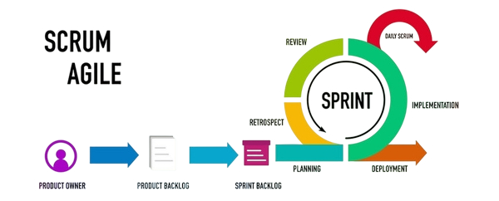
The researchers utilized a quantitative research method to collect measurable data from respondents regarding the Electoral Commission Voting System (ECVS). Data were gathered using structured survey questionnaires with close ended questions to evaluate system performance, efficiency, and user satisfaction. The study employed a descriptive research design to analyze the existing problems in election procedures, including delays, inaccuracies, and lack of transparency. The results served as the basis for system improvement and evaluation.

Figure 6 Agile Scrum Development Process
The Agile Scrum methodology guided the system development of the Electoral Commission Voting System (ECVS). The development process was carried out through iterative cycles called sprints, allowing continuous improvement, testing, and feedback integration. Each sprint produced a functional increment of the system until full implementation was achieved.
Product Owner
The Product Owner will represent the stakeholders, including the Electoral Commission (ELECOM), students, and administrators. The Product Owner will be responsible for defining system requirements and prioritizing features based on the needs of the users.

Product Backlog
The product backlog will contain the complete list of system requirements identified through interviews and surveys. These will include mobile voting, automated vote counting, blockchain-based vote verification, network-restricted voting, candidate management, and real-time result generation.
Sprint Backlog
From the product backlog, selected features will be organized into the sprint backlog. These tasks will be planned for development within a specific sprint cycle.
Planning
The planning phase will identify the system requirements, project objectives, and important features of the Electoral Commission Voting System (ECVS). The development team will organize tasks, schedules, and development priorities for each sprint cycle.
Implementation
During implementation, the developers will create system components such as user authentication, candidate management, mobile voting, vote counting, and blockchain logging. Coding, testing, and debugging will be continuously performed to ensure system functionality and security.
Daily Scrum
Daily Scrum will refer to short meetings conducted by the development team to discuss progress, completed tasks, current issues, and upcoming activities. This process will help maintain coordination and improve team productivity throughout the development process.
Review
The review phase will evaluate the completed system features after each development cycle. Feedback from users, students, and administrators will be gathered to assess system performance, usability, and reliability.
Retrospect
The retrospect phase focuses on identifying strengths, weaknesses, and possible improvements in the development process. The team discusses challenges encountered and applies necessary adjustments for future system enhancement.
Deployment
Deployment will be the final stage where the completed Electoral Commission Voting System (ECVS) will be integrated and implemented within the campus environment. The mobile application and web-based administrative platform will be made accessible to authorized users for actual election operations.

3.2 Data Gathering Procedure
The data gathering process was conducted systematically. First, the researchers prepared the survey questionnaire and interview guide. Second, permission was secured from school authorities. Third, respondents were selected and surveys were distributed either physically or online. Interviews were also conducted with selected participants, especially Electoral Commission personnel.
After data collection, responses were tabulated, analyzed, and interpreted using statistical tools. All data were handled with confidentiality.

3.2.1 Research Instrument
The researchers used survey questionnaires and interview guides as the primary research instruments for gathering data in this study. The survey questionnaire was designed to evaluate the Electoral Commission Voting System (ECVS) in terms of usability, efficiency, accuracy, security, and user satisfaction. The questionnaire utilized a 5-point Likert scale to measure the respondents’ level of agreement with each statement.
The interview guide was used during interviews with the University Student Government (USG) moderator and the Electoral Commission (ELECOM) chairperson to gather additional information regarding the current election process, existing challenges, and recommendations for system improvement.
The following indicators were used in evaluating the proposed system:
Usability - Ease of navigation and interaction with the system
Efficiency - Speed of voting and result generation
Accuracy - Correct recording and tallying of votes
Security - Protection of voter identity and vote integrity
User Satisfaction - Overall user experience

3.2.2 Sampling Method
The study used purposive sampling to select respondents who had direct experience with the election process at University of Science and Technology of Southern Philippines (USTP) Oroquieta Campus. The study involved 69 respondents, consisting of one University Student Government (USG) moderator, one Electoral Commission (ELECOM) chairperson, and 67 students.
The selection criteria required participants to possess relevant knowledge and actual experience with the existing manual election system which allowed them to give essential feedback about its operational functions and current problems and system deficiencies. The USG moderator and ELECOM personnel were selected because they held administrative positions which required them to oversee election operations whereas the student respondents were chosen because they had experience voting on campus.
The targeted sampling method collected data which reflected actual experiences and operational knowledge of the election system. Researchers obtained trustable experience based data from specific groups which enabled them to discover system problems and determine essential features for building the Electoral Commission Voting System (ECVS).

3.2.3 Statistical Treatment of Data
To systematically analyze the collected data, the researchers used descriptive statistical methods such as frequency, percentage, and weighted mean. These statistical tools were utilized to evaluate the system’s performance, efficiency, accuracy, security, and user satisfaction.
The weighted mean was used to determine the overall evaluation of the system based on responses gathered through a 5 point Likert scale. The formula for weighted mean is:
$$\overline{x}=\frac{∑fx}{N}$$
Where:
x̄ = Weighted Mean
$∑fx$ = Sum of the products of frequency and corresponding weight
N = Total number of respondents
The results were presented in tables and interpreted to support the findings of the study.
Table 2. Likert Scale Table
Scale | Description
5 | Strongly Agree
4 | Agree
3 | Neutral
2 | Disagree
1 | Strongly Disagree

3.3 Description of the Current System
The current voting systems used by most organizations depend on either complete manual operation or their combination with automated systems which process paper ballots and execute manual vote counting. The method encounters several problems, including:
- Delays in vote counting and result generation
- Human mistakes make the system more vulnerable to errors
- The system permits unauthorized access which allows tampering with votes and committing election fraud
- The system lacks both transparent operation and auditing capabilities
- This system needs a development of a new voting method which provides greater security and operational efficiency and complete voting process visibility.

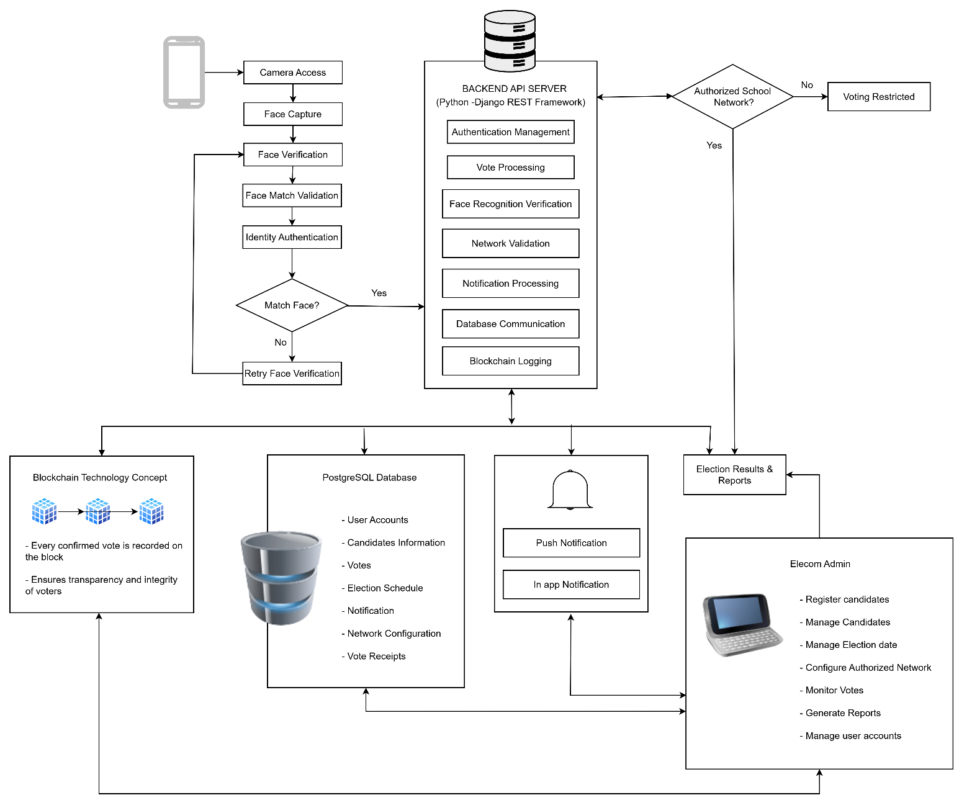
3.4 System Architecture and Development
Figure 7 System Architecture and Development

The Electoral Commission Voting System (ECVS) functions as the main election management system for campus elections according to Figure 7, which shows its complete system architecture. The system connects student voters, administrators, and the backend server through a mobile and web-based interface. Students can log in, access the system through an authorized school network, view candidates, and cast their votes securely. The system requires users to validate their network access before they can submit votes because this measure helps prevent unauthorized voting.
The server handles all transaction processing which includes user authentication and vote recording and result generation activities. The database maintains user information and candidate information and election data. The system records votes using cryptographic hashing and ledger logging mechanisms for transparency and tamper detection which create a transparent voting system that prevents any data manipulation. The system enables administrators to control candidate activities and set election times and watch voting processes and create different types of reports.
The diagram shows how system components interact with each other to protect data transmission across the platform, which leads to an election process that operates efficiently and maintains complete transparency and trustworthiness.

3.4.1 Overview of the Proposed System
The Electoral Commission Voting System (ECVS) operates as an online voting system that uses cryptographic hashing and ledger-based verification for secure vote recording and transparency. The system enables voters to securely cast their ballots through online voting while the system keeps permanent records of all voting activities in a digital ledger that can detect unauthorized modifications through cryptographic verification.. Voters' choices get protected through encryption, which transforms each ballot into a cryptographically verified voting record. This process involves cryptographic hashing to create links between current votes and previous voting records. The system guarantees that votes remain permanent after their initial recording.
The system architecture consists of the following components:

Frontend Interface; User interface for voters and administrators

Backend Server; Handles system logic and processing

Cryptographic Ledger System; Stores cryptographically verified voting records and transaction logs

Database; Stores user credentials and non-sensitive information

3.4.2 System Objectives
- The system needs to create a secure voting platform which maintains operational reliability.
- The system must deliver vote recording system which guarantees both accurate results and protection against unauthorized changes.
- The system needs to provide the ability to count votes in real time.
- The system needs to establish better ways for people to see what happens during the voting process.
- The system needs to develop features which make it easier for users to access the system while also increasing their overall satisfaction.

3.4.3 System Tools and Requirements
This section presents the tools, technologies, and requirements used in the development of the Electoral Commission Voting System (ECVS). These components ensure that the system operates efficiently, securely, and reliably across different platforms for both students and administrators.
Table 3 Programming Languages uses in Development
Programming languages | Description
Dart | Used for developing the Flutter-based mobile application for student voters.
Python | Used for backend development, API processing, authentication, and vote management.

Table 4 Scripting Language use in development
Scripting language | Description
JavaScript | Used for interactive web functionalities and frontend scripting.

Table 5 Markup Language uses in Development
Markup Language | Description
HTML | Used to structure and display content for the web-based administrative interface.

Table 6 Style Sheet Language uses in Development
Style Sheet Language | Description
CSS | Used to design and improve the appearance and layout of the web interface.

Hardware Requirements
Table 7. Hardware Requirements
Component | Description
Mobile Devices (Students/Voters) | The research study requires devices which support Flutter applications through their operation on both smartphones and tablets. The devices need to meet basic requirements which include adequate processing capabilities and memory capacity and reliable internet access.
Desktop Computers (ELECOM Admin) | Computing devices like desktops or laptops with the capacity to run contemporary web browsers to enable access to a web-based administrative system.
Server Infrastructure | Servers used to host the backend system and database. Handles API requests, vote processing, authentication, and blockchain logging. Specifications depend on system load and number of users.
Network Infrastructure | Campus Wi-Fi or LAN is needed for maintaining the system for receiving "school only" ballots, providing that students can access online voting only in the approved school networks.

Software Requirements
Table 8 Software Requirements
Software | Description
Database | PostgreSQL Database Used to store user credentials, candidate information, voting records, and election data.
Front End Development | Flutter Framework (Dart) Used to develop the mobile application interface for student voters.
Backend Development | Python (FastAPI or Django REST Framework) Used to handle server-side logic, authentication, vote processing, and API communication.
Cryptographic Hashing Libraries | Used for vote verification, tamper detection, and secure ledger recording.
Development Tools | Visual Studio Code Used for coding, debugging, and system development.

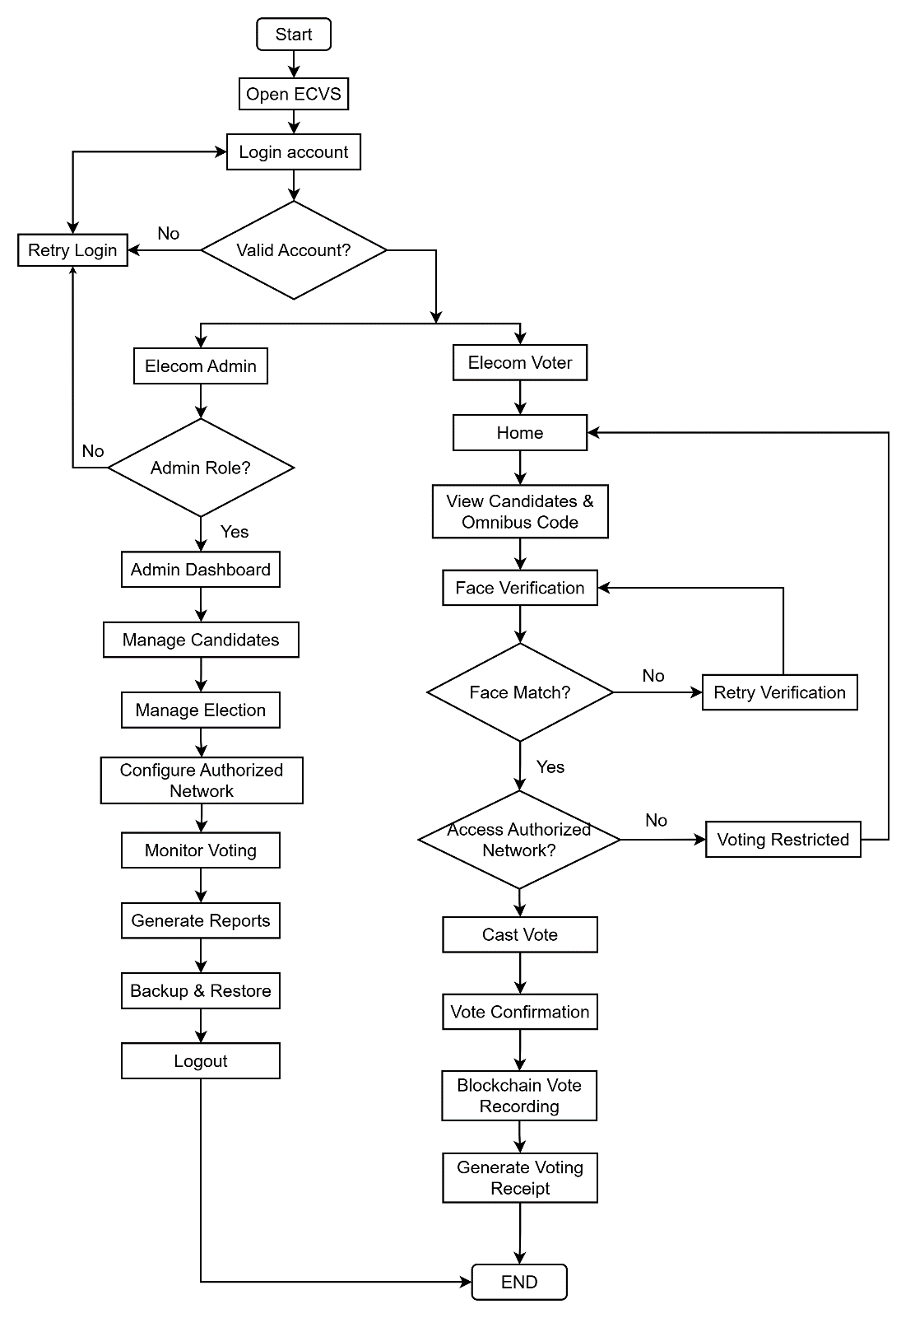
3.4.4 System Flow/Functions (Diagram: FLOWCHART)
Figure 8 Flowchart Diagram

Figure 8 shows how users interact with the Electoral Commission Voting System (ECVS) from their first login until they complete their voting process. It shows the complete process of authentication together with role selection and candidate administration and network verification and voting and result creation for both administrators and student voters. The flowchart shows how network restricted voting and safe vote processing work together to create a structured voting system that operates efficiently while ensuring trustworthy election procedures.

3.4.5 Scope and Limitations of the System
This project developed the Electoral Commission Voting System (ECVS), a digital platform that allows students to participate in campus elections through a mobile application while the Electoral Commission (ELECOM) manages election processes through a web based system. The system provides users with the ability to log in and view candidates and cast votes while receiving voting receipts. The system gives administrators permission to control candidate information and set election times while observing voter behavior and producing official documents.
The system has limitations. The system serves campus elections at the University of Science and Technology of Southern Philippines Oroquieta Campus. The system requires modifications before other institutions can use it. The system depends on users having a stable internet connection to complete three tasks: login and vote submission and receive real time updates. The network restricted voting feature requires users to be connected to authorized school networks which limits access outside the campus. The blockchain implementation exists only within a private or simulated environment which does not support public cryptocurrency transactions. The system uses institutional credentials for authentication without connecting to national identity verification systems.


3.4.6 Calendar of Activities (Gantt Chart)
Figure 9 Gantt Chart

The 12-month project schedule for the Electoral Commission Voting System (ECVS) development shows all project phases from planning through system launch in Figure 4. The project activities show their organization for two main purposes which include development efficiency and the successful integration of essential features like blockchain and network-restricted voting and the system's scheduled completion.

3.5 Conceptual Design and Implementation

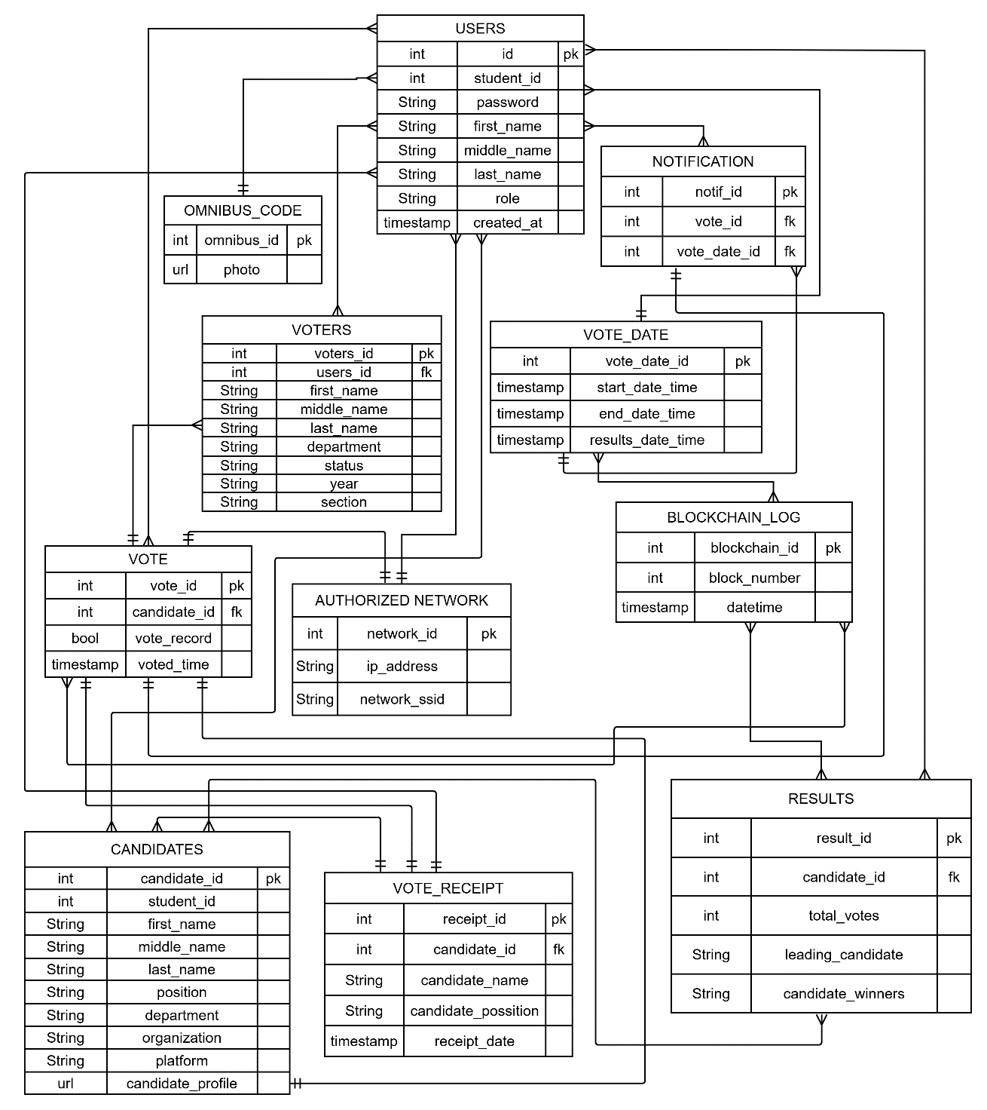
3.5.1 Database Design (Diagram: Entity Relationship Diagram.)
Figure 10 Database Design

The system design for the Electoral Commission Voting System (ECVS) database appears in Figure 10 which displays table structures that establish system workflows through their connections. The core tables Users, Voters, and Candidates maintain key data which includes user credentials, student details, roles, candidate profiles, and organizational affiliations. The tables enable system users to authenticate their identity while the system recognizes their assigned roles and handles candidate information. The Blockchain_Log table stores cryptographic hashes and transaction logs used for vote verification and tamper detection.
The Vote and Vote_Receipt tables handle all voting transactions which include selected candidates, vote records, timestamps, and generated voting receipts. The Vote_Date table defines the election schedule which includes start and end times to ensure that voting activities are properly controlled within the designated period. The Results table contains total vote counts and leading candidates and final winners which enable automatic result calculation and reporting.
The Authorized_Network table enables network-restricted voting through its function of storing permitted IP addresses and network identifiers that grant voting access to approved school networks. The Notification table controls all system alerts which include voting status and updates while the Blockchain_Log table maintains blockchain information through block numbers and timestamps to protect vote integrity and ensure transparency and permanent recordkeeping.

3.5.2 System Design

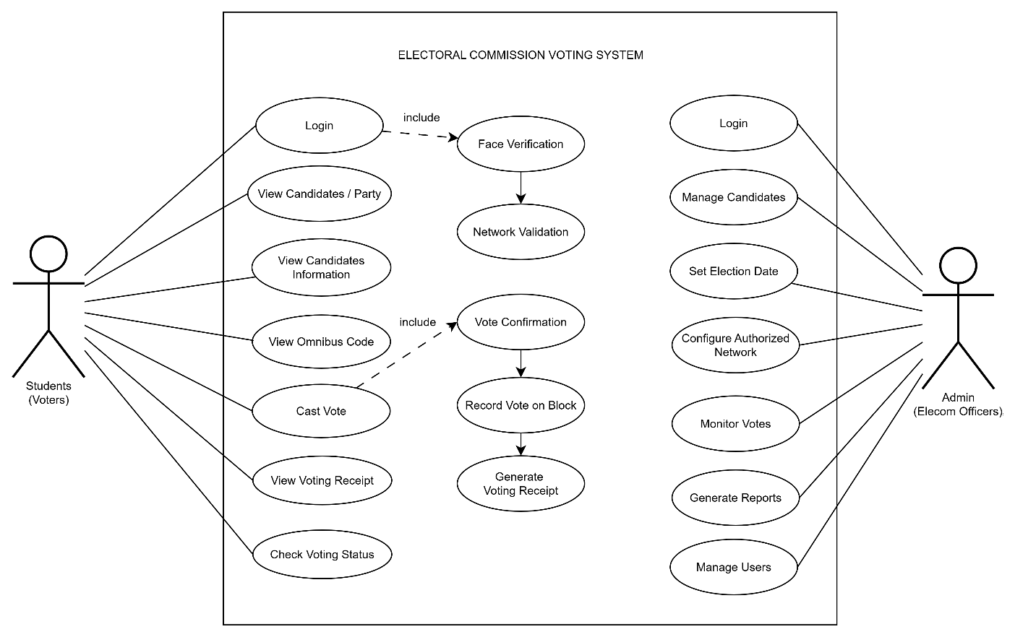
Use Case Diagram

Figure 11 Use Case Diagram

Figure 11 presents the Use Case Diagram of the Electoral Commission Voting System (ECVS), illustrating the interaction between two main user roles: Students (Voters) and Admin (ELECOM Officer). Students can access the system by logging in, viewing the list of candidates, and casting their votes during the election period.
On the other hand, the Admin (ELECOM Officer) manages the overall election process through the system. The admin is responsible for managing candidates, setting the election date, configuring the authorized network for voting restrictions, and generating reports for monitoring and evaluation purposes. The diagram highlights how both users interact with the system to ensure a secure and organized voting process.

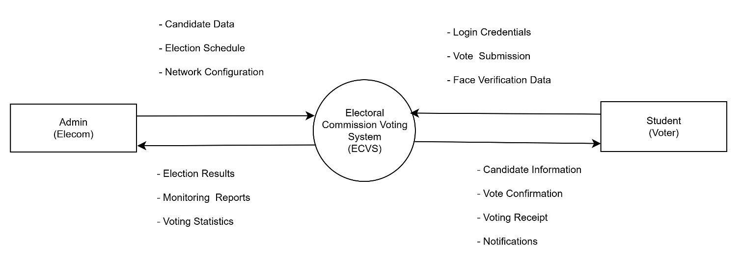
Context Diagram

Figure 12 Context Diagram

The Electoral Commission Voting System (ECVS) connects three external campus election entities through its main platform which consists of Admin (ELECOM) and Student Voters and Authorized Network members. The Admin (ELECOM) sends candidate information and election timetable details and network setup specifications to the system while the system provides electoral results and monitoring reports back to the Admin. Students use the system to log in and view candidates while they cast their votes and the system gives them access to candidate information and vote receipt details and status updates. The Authorized Network maintains system operations through its network authentication process and access management system which permits voting only on designated school networks to enhance security and manage voter access. The proposed system aims to provide USTP Oroquieta campus elections with a secure automated voting system which maintains transparency throughout digital voting.

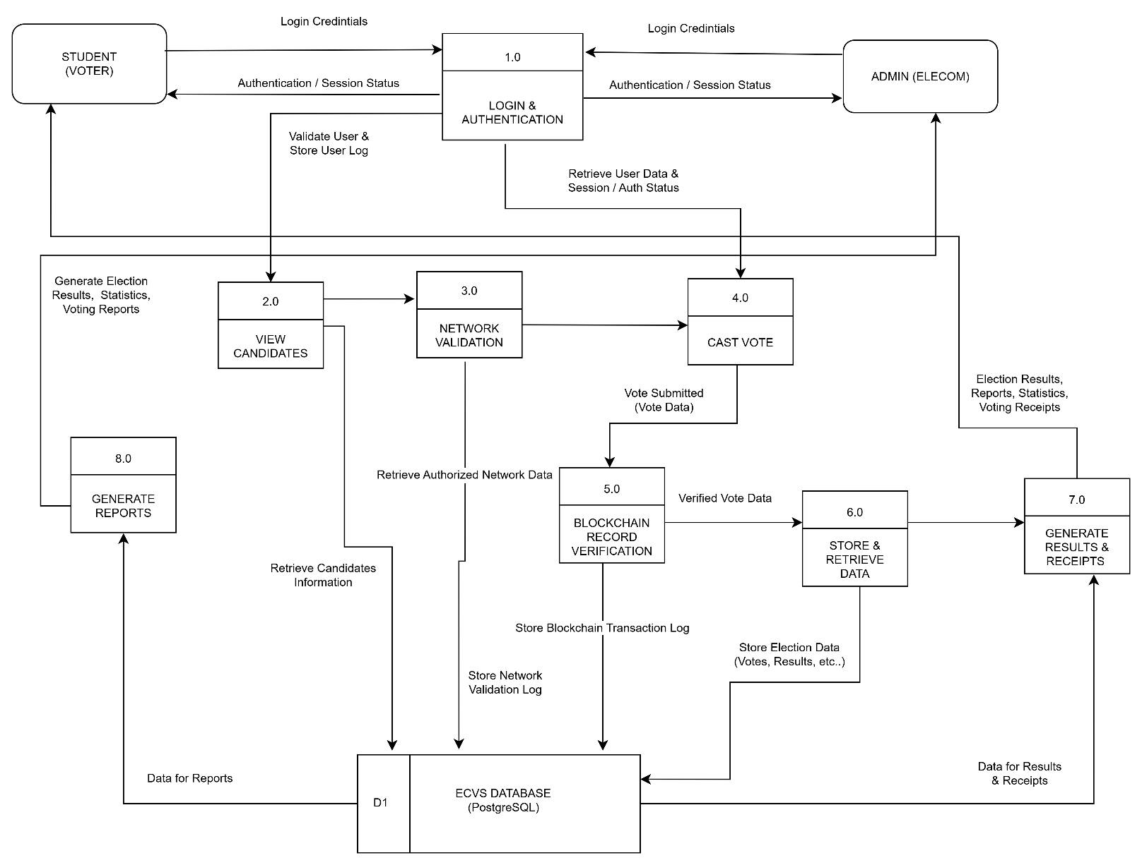
Data Flow Diagram

Figure 13 Dataflow Diagram

The Electoral Commission Voting System (ECVS) displays its data flow structure through Figure 13, which shows how students and voters and administrators interact with the system operations and its databases. The process begins with login and authentication, where user credentials are verified using the users database. Voters who pass the network validation process can access candidate information before casting their votes.
The voting process begins when a voter submits their ballot because the system records their choice through a blockchain system that protects the data until it gets stored in the vote database. The system uses the stored information to produce election outcomes and voting receipts which both voters and administrators can access. The administrator controls all aspects of candidate information and system configuration while monitoring the voting process. The diagram shows that the system enables secure transparent digital voting because it handles data according to proper methods and links its different processes.

CHAPTER IV
RESULTS AND DISCUSSIONS

This chapter presents the outcomes of the development and implementation of the Electoral Commission Voting System (ECVS), highlighting the challenges encountered during its development and the strategies used to address them. Furthermore, it discusses how the system effectively addresses the identified problems in the existing manual election process and fulfills the objectives stated in the study. The chapter also presents the results of the system evaluation in terms of usability, efficiency, accuracy, security, and user satisfaction, providing an assessment of the system’s effectiveness in improving the campus electoral process at the University of Science and Technology of Southern Philippines (USTP) Oroquieta Campus.

4.1 Discussions
Discussion No. 1.
Discussion No. 2.
Discussion No. 3.
Discussion No. 4.
Discussion No. 5.
Discussion No. 6.

BIBLIOGRAPHY

ACE Electoral Knowledge Network. (2022). Electoral management and voting processes. https://aceproject.org
International IDEA. (2021). Electoral processes and challenges. https://www.idea.int
Yaga, D., Mell, P., Roby, N., & Scarfone, K. (2021). Blockchain technology overview (NISTIR 8202). National Institute of Standards and Technology.
Zheng, Z., Xie, S., Dai, H., Chen, X., & Wang, H. (2022). Blockchain challenges and opportunities: A survey. International Journal of Web and Grid Services, 18(2), 123–146.
Kshetri, N., & Voas, J. (2021). Blockchain-enabled e-voting. IEEE Software, 38(1), 79–85.
Commission on Elections (COMELEC). (2022). Digital transformation in electoral processes.
Mindanao State University. (2021). Development of an online voting system for campus elections [Undergraduate thesis].

University of the Philippines. (2021). Secure authentication in electronic voting systems [Research study].
Cebu Technological University. (2021). Web-based voting system for student elections [Undergraduate thesis].
Polytechnic University of the Philippines. (2021). Automated election system with database integration [Research study].

APPENDICES

APPENDIX A
Interview Questionnaire
for USG Moderator and ELECOM Chairperson

Name (Optional): __________________________________ Date: __________
Designation/Position Title: _____________

1. What is ELECOM? ________________________________________________________________________________________________________________________________________________________________________________________________________________________________________________________________________
2. How often do you conduct elections? ________________________________________________________________________________________________________________________________________________________________________________________________________________________________________________________________________
3. What challenges do you face in conducting elections? Why? ________________________________________________________________________________________________________________________________________________________________________________________________________________________________________________________________________
4. What did you do to solve this problem? What did we did? ________________________________________________________________________________________________________________________________________________________________________________________________________________________________________________________________________

Interview Questionnaire
for Students Who Have Experienced Campus Elections

Name (Optional): _________________________________ Date: ___________
Course/Year/Section: ____________ Designation/Position Title: ___________

1. Have you experience joining the election activities in our campus? Share to me your experience. ________________________________________________________________________________________________________________________________________________________________________________________________________________________________________________________________________

2. What are those challenges do you encountered? ________________________________________________________________________________________________________________________________________________________________________________________________________________________________________________________________________

3. What did you do to solve this problem? ________________________________________________________________________________________________________________________________________________________________________________________________________________________________________________________________________

APPENDIX B
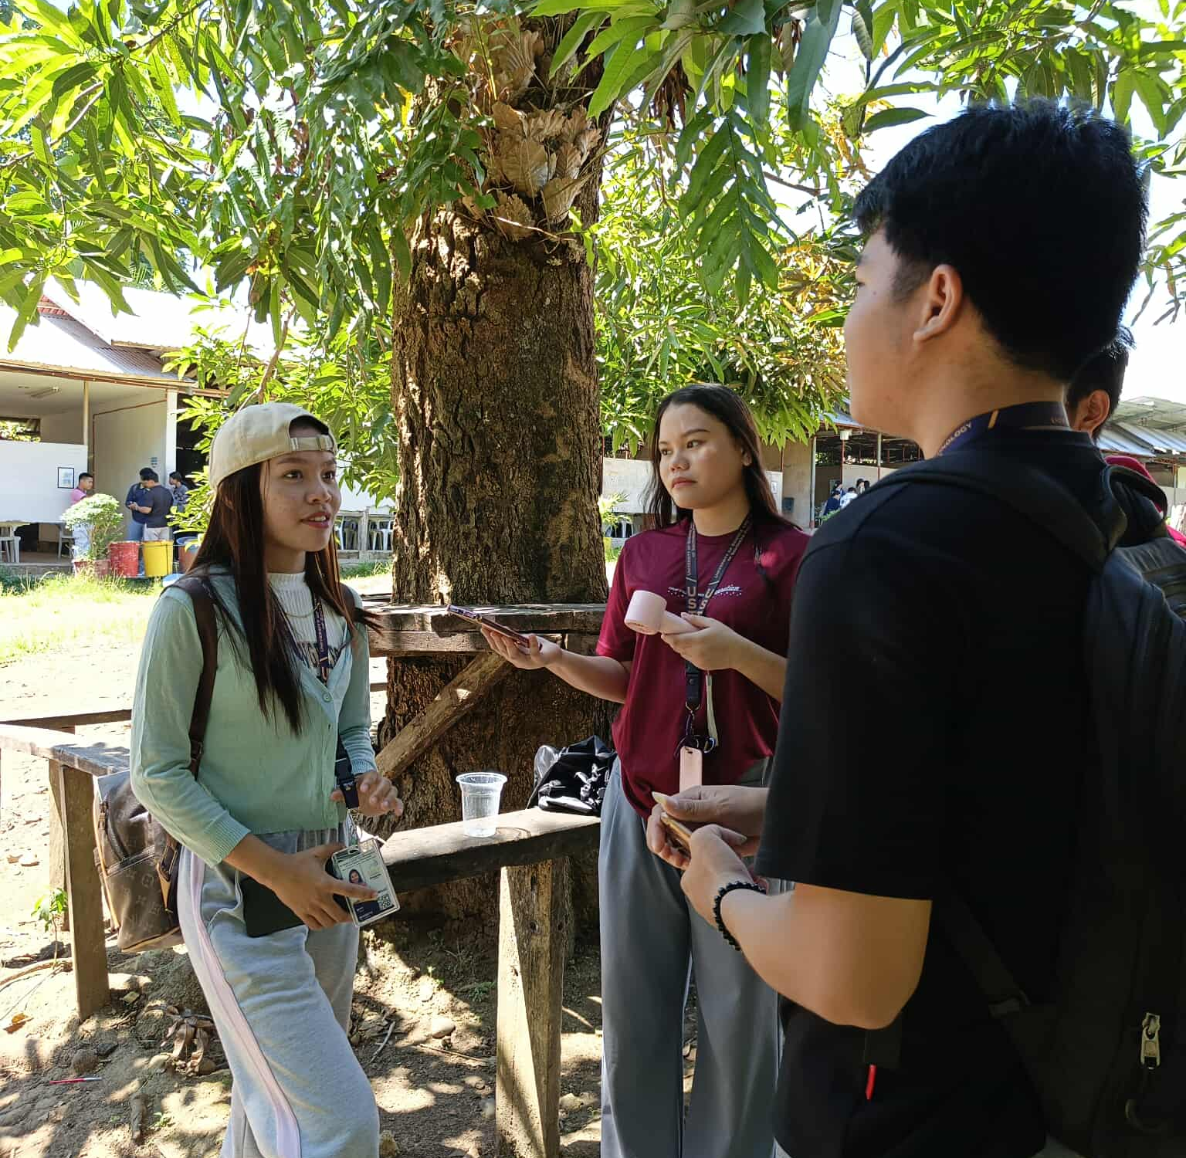
DATA GATHERING


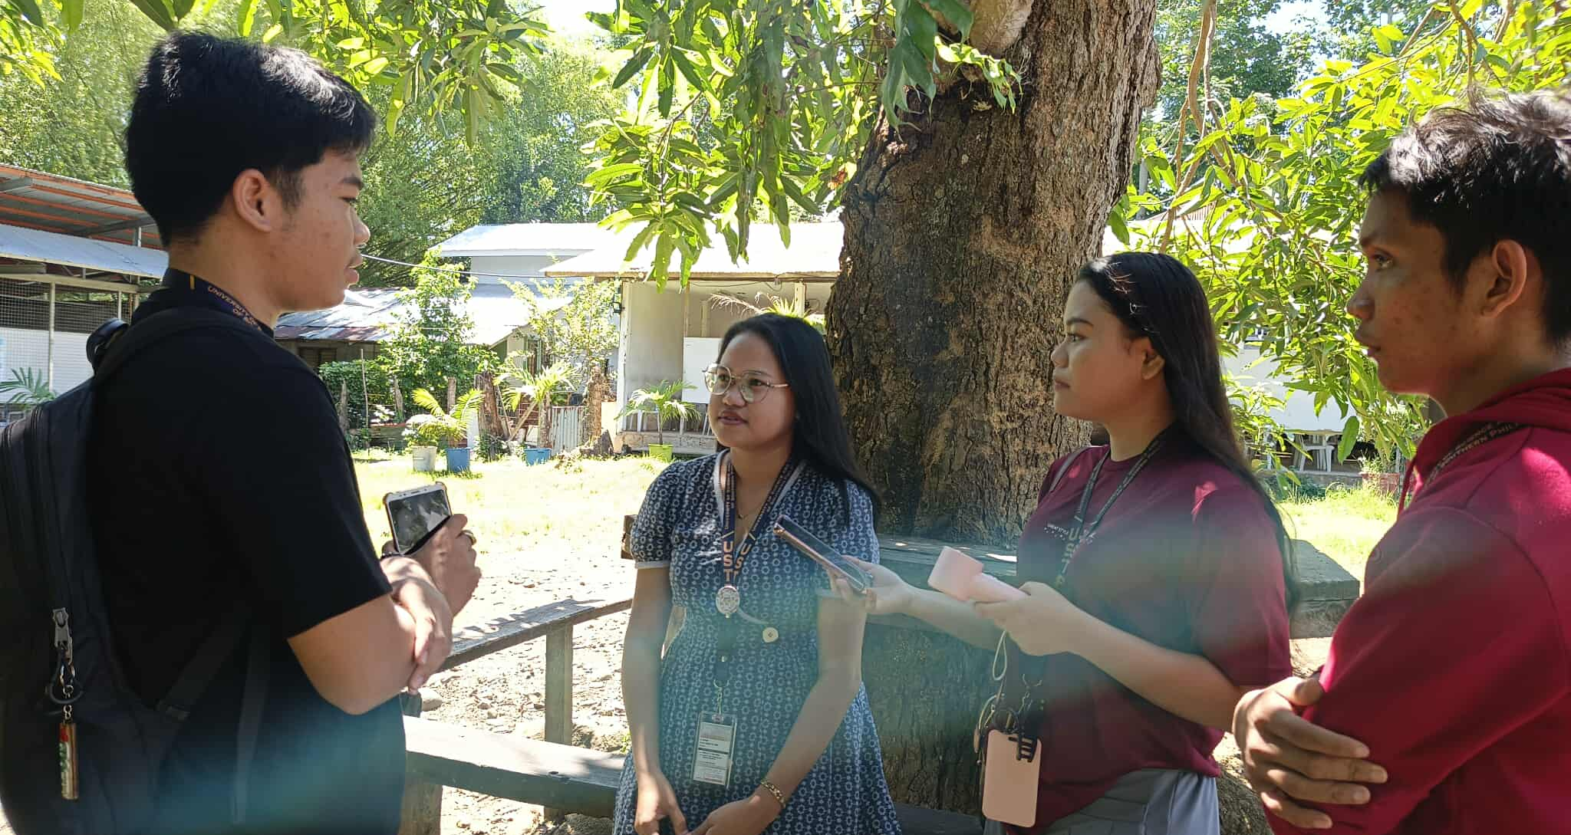

INTERVIEW WITH USG MODERATOR


INTERVIEW WITH ELECOM CHAIRPERSON
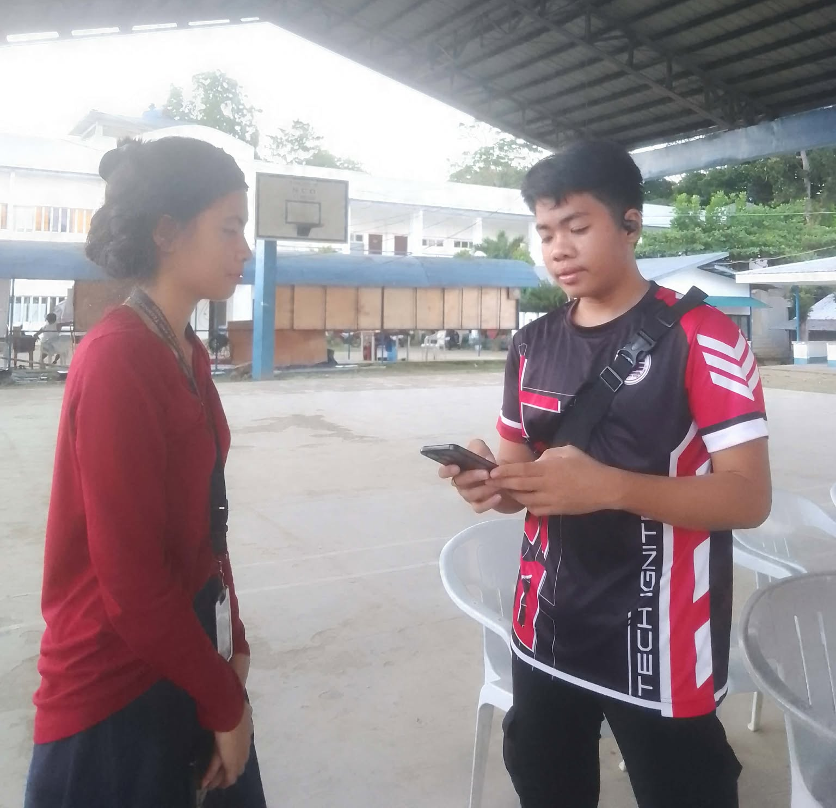

CURRICULUM VITAE


REDJAN PHIL S. VISITACION
Purok 4, Mobod
Oroquieta City Misamis Occidental
09534181760
visitacionredjanphils@gmail.com

A passionate and creative student with a strong interest in photography, Graphic design, and programming. Skilled in video editing and always eager to learn new technologies.

PERSONAL DATA
Place of Birth: Purok 4 Mobod, Oroquieta City Misamis Occidental
Birthdate: 07/09/2005
Age : 21
Civil Status: Single
Citizenship : Filipino
Religion : Roman Catholic
Mother’s Name: Rosita S. Visitacion
Father’s Name: Rogelio C. Visitacion

TECHNICAL SKILLS
Photographer
Graphic Design
Programmer
Video Editing

INTERESTS & HOBBIES
Hacking
Social Media

EDUCATIONAL BACKGROUND

2023 - 2027 | University of Science and Technology of Southern  Philippines  Bachelor of Science in Information Technology
2021 - 2023 | Deor & Dune Academe School of Technology, Inc.  Purok – 1 Mobod, Oroquieta City
2017 - 2021 | Mobod Integrated School  Purok – 2 Mobod, Oroquieta City
2011 - 2017 | Mobod Integrated School  Purok – 2 Mobod, Oroquieta City

LEADERSHIP BACKGROUND
2023 - 2024 | SITE Committee on Digital Arts and Documentation  USTP OROQUIETA
2024 - 2027 | Attended Trailblazers Leadership Summit  USTP OROQUIETA
2024 | IT Days Mobile Photo Contest Facilitator  USTP OROQUIETA
2024 - 2026 | Intramural Photo Contest Facilitator  USTP OROQUIETA
2024 - 2025 | Arts Month Photo Contest Facilitator  USTP OROQUIETA
2024 - 2025 | Arts Month Short Film Facilitator  USTP OROQUIETA
2024 - 2025 | Attended Basic Life Support Training  USTP OROQUIETA
2025 | IT Days Film Viewing Facilitator  USTP OROQUIETA
2025 | IT Days HACKathon Facilitator  USTP OROQUIETA
2024 - 2026 | Active Certified Computer-Enhance Students Society President  USTP OROQUIETA
2024 - 2026 | Active Certified Computer-Enhance Students Society Director in Developers and Robotics  USTP OROQUIETA
2024 - 2027 | University Student Government IT Representative  USTP OROQUIETA
2025 | Attended General Assembly for Accredited Student Organizations  USTP CAGAYAN DE ORO
2025 | Attended Leadership training & workshop, with Vice President of Student Affairs and Services  USTP CAGAYAN DE ORO
2025 - 2027 | Attended Leadership Through Evaluation, Alignment, and Development Training for the University Student Government officers.  USTP OROQUIETA
2025 | Attended Oroquieta Youth Leadership Summit with 10th Infantry "Steady On" Battalion  CAMP BURGOS OROQUIETA

AWARDS AND CERTIFICATES
2021 - 2023 | Senior High With Honors  DEOR & DUNE OROQUIETA
2023 | Computer System Servicing (NCII)  DEOR & DUNE OROQUIETA
2023 | Intramurals Photo Contest 3rd Placer  USTP OROQUIETA
2023 | ARDUINO IOThink Olympics 2nd Placer  USTP OROQUIETA
2024 | NSTP Certificates  USTP OROQUIETA
2024 | Microsoft Certificates  ONLINE
2025 | Google Gemini Certificates  ONLINE
2025 | Code Creed Certificates  ONLINE
2025 | (WAKAN) Short Film Champion  USTP CAGAYAN DE ORO
2025 - 2026 | As a Break trough Student leader  USTP OROQUIETA
2025 | As a Best Student Organization (ACCESS)  USTP OROQUIETA
2025 - 2026 | DICT Digital Bayanihan Para sa Kabatang Ligtas at Protektado Online and Cybersecurity 101 Certificates  USTP OROQUIETA
2026 | HACKERDNA Cyber Security Labs Capture the Flag 101 Certificates  ONLINE
2026 | Mediterranean Journal of Basics and Applied Science Certificate of Publication – Assessment of Concerns Cybersecurity Awareness  ONLINE

REFERENCES
JUBILEE S. DAGA-ANG, MIT
Chairman of the IT Department
University of Science and Technology of Southern Philippines
Oroquieta Campus – Oroquieta City, Misamis Occidental
Jubilee.daga-ang@ustp.edu.ph

HANES A. ONGOS
IT Instructor
University of Science and Technology of Southern Philippines
Oroquieta Campus – Oroquieta City, Misamis Occidental
hanes.ongos@ustp.edu.ph

